A.1
CREATE DATABASE CollegeDB;
USE CollegeDB;
CREATE TABLE Course (
CourseID INT PRIMARY KEY,
CourseName VARCHAR(50) NOT NULL,
Fees DECIMAL(10,2) NOT NULL
);
CREATE TABLE Student (
StudentID INT PRIMARY KEY,
StudentName VARCHAR(50) NOT NULL,
CourseID INT,
City VARCHAR(30),
Marks INT,
Email VARCHAR(60),
FOREIGN KEY (CourseID) REFERENCES Course(CourseID)
);
INSERT INTO Course VALUES
(101, 'BSc IT', 45000.00),
(102, 'BCA', 40000.00),
(103, 'BSc CS', 42000.00),
(104, 'Data Science', 55000.00);
INSERT INTO Student
(StudentID, StudentName, CourseID, City, Marks, Email)
VALUES
(1, 'Rahul Sharma', 101, 'Mumbai', 78, 'rahul@gmail.com'),
(2, 'Priya Patil', 102, 'Pune', 85, 'priya@gmail.com'),
(3, 'Aman Verma', 103, 'Nashik', 67, 'aman@gmail.com'),
(4, 'Sneha Joshi', 101, 'Mumbai', 91, 'sneha@gmail.com'),
(5, 'Karan Mehta', 102, 'Thane', 74, 'karan@gmail.com'),
(6, 'Neha Shah', 101, 'Pune', 88, 'neha@gmail.com'),
(7, 'Rohan Desai', 103, 'Mumbai', 69, 'rohan@gmail.com'),
(8, 'Meera Kulkarni', 102, 'Nashik', 82, 'meera@gmail.com'),
(9, 'Arjun Nair', 101, 'Thane', 59, 'arjun@gmail.com'),
(10, 'Divya More', 102, 'Mumbai', 93, 'divya@gmail.com');
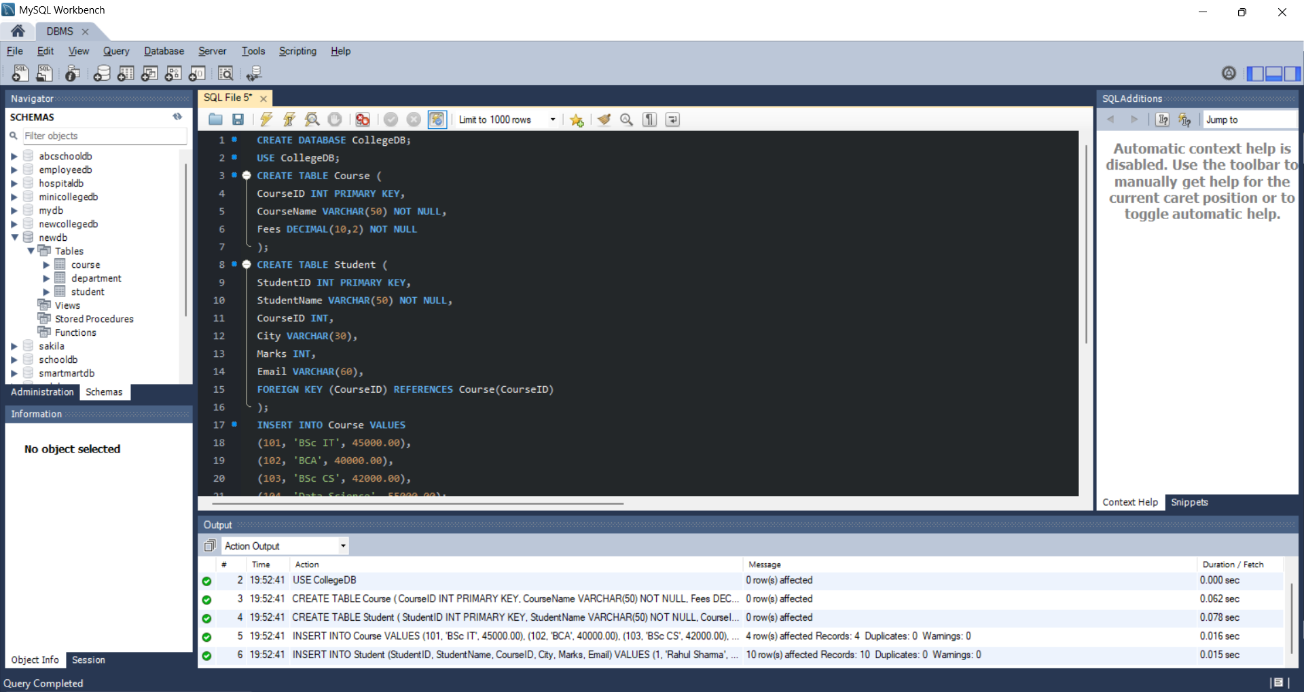

A.2
CREATE VIEW StudentBasicView AS
SELECT StudentID, StudentName, City, Marks
FROM Student;
SELECT * FROM StudentBasicView;
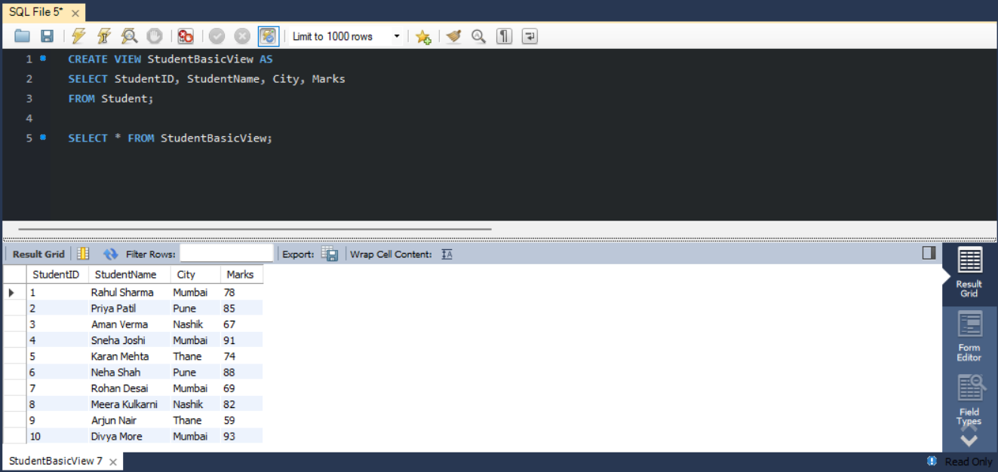

A.3
CREATE VIEW StudentCourseView AS
SELECT
Student.StudentID,
Student.StudentName,
Student.City,
Student.Marks,
Course.CourseName,
Course.Fees
FROM Student
INNER JOIN Course
ON Student.CourseID = Course.CourseID;
SELECT * FROM StudentCourseView;
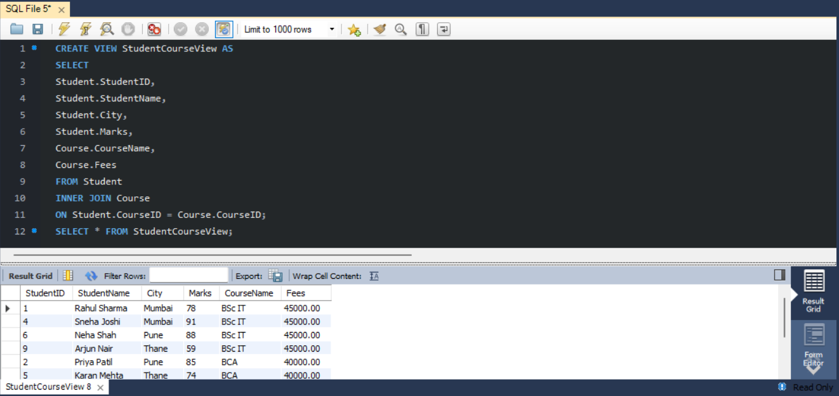

A.4
SELECT StudentName, City, CourseName, Marks
FROM StudentCourseView
WHERE City = 'Mumbai';
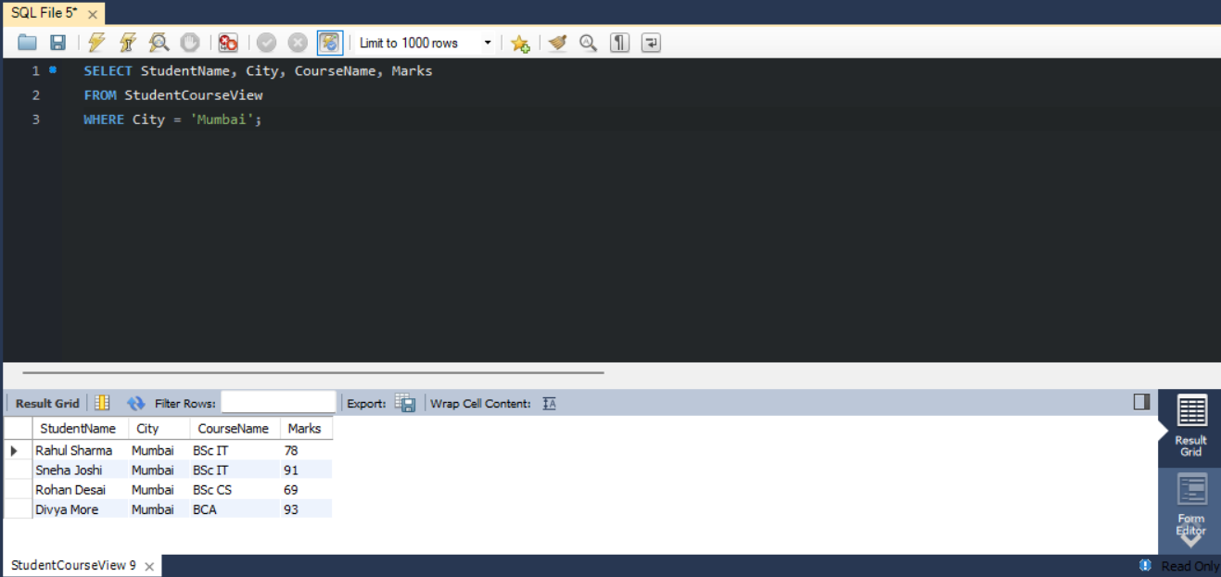
A.5
SELECT StudentName, CourseName, Marks
FROM StudentCourseView
ORDER BY Marks DESC;
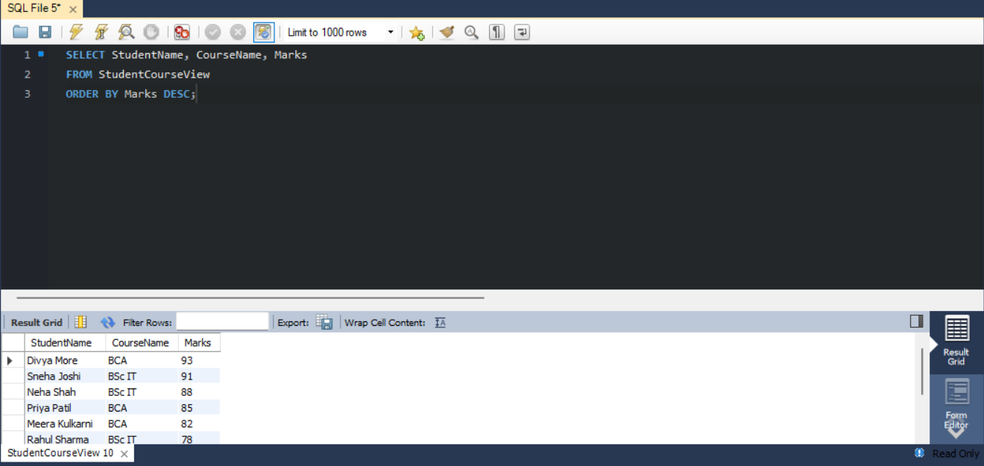

A.6
CREATE VIEW ManagementReportView AS
SELECT
Course.CourseName,
COUNT(Student.StudentID) AS TotalStudents,
AVG(Student.Marks) AS AverageMarks,
MIN(Student.Marks) AS LowestMarks,
MAX(Student.Marks) AS HighestMarks
FROM Course
LEFT JOIN Student
ON Course.CourseID = Student.CourseID
GROUP BY Course.CourseName;
SELECT * FROM ManagementReportView;
